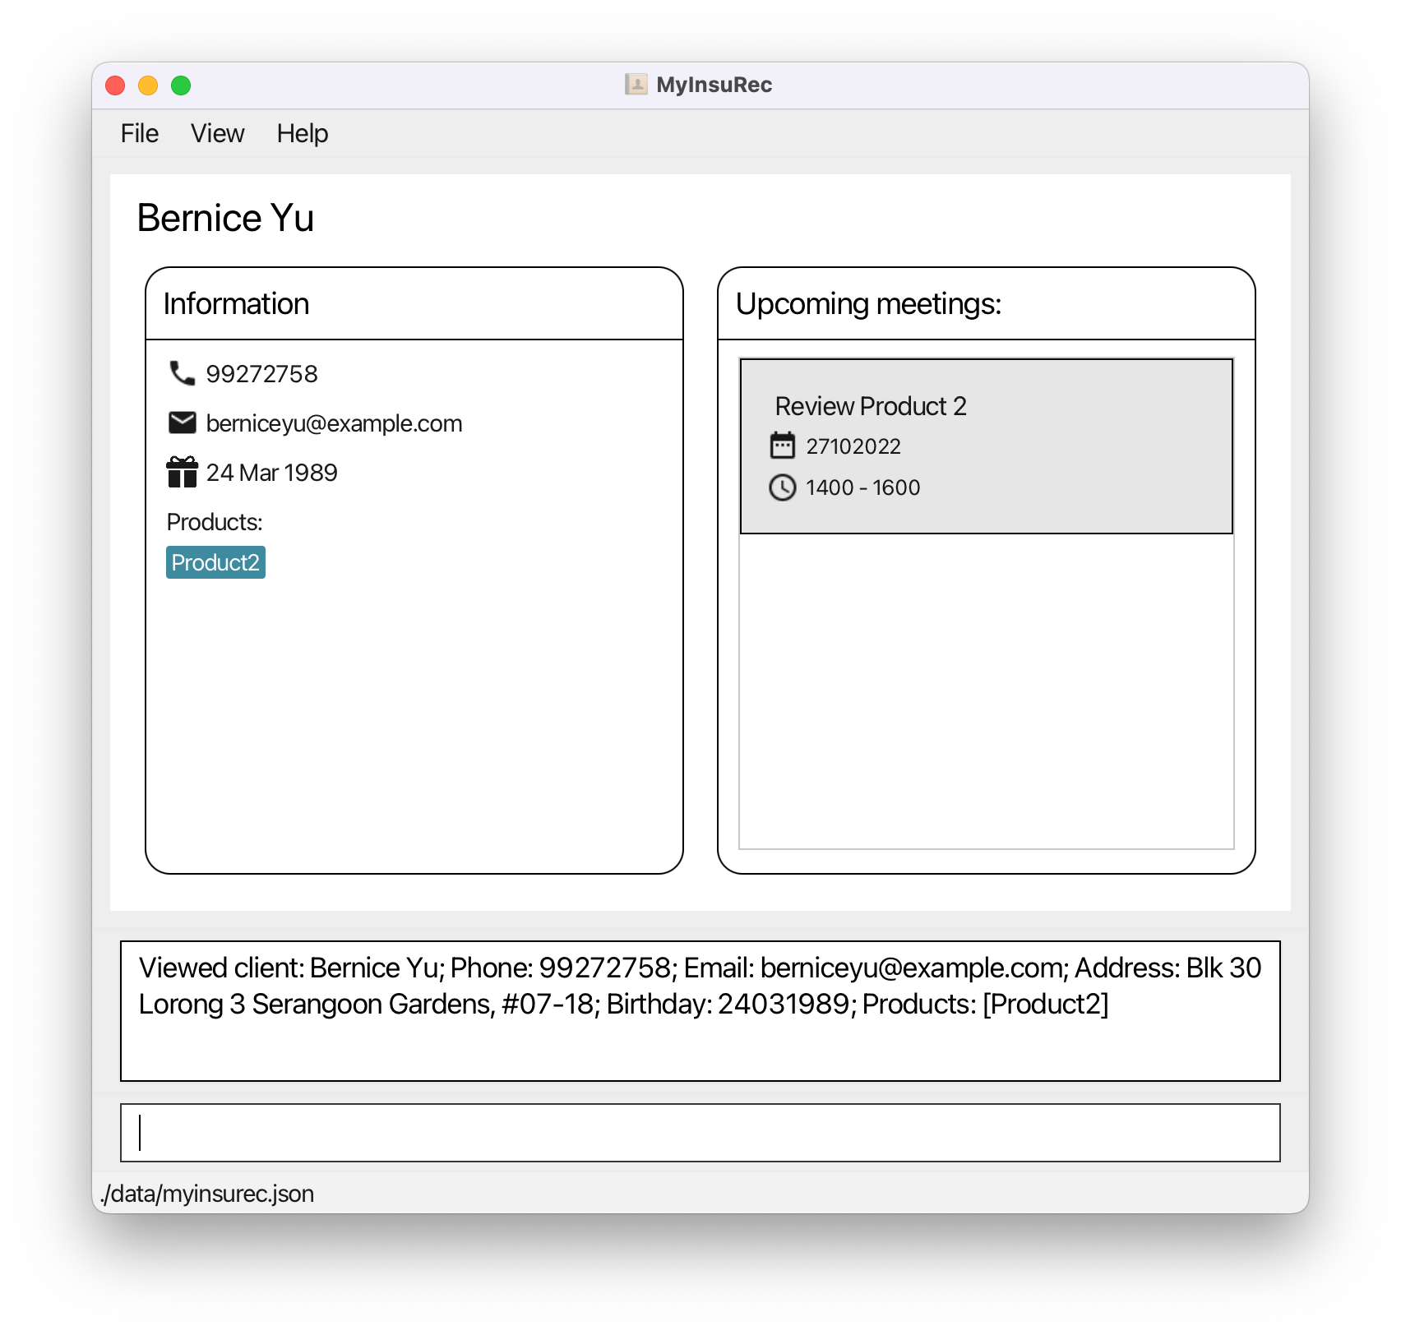

Client Name

Meeting Time

Meeting Date

Client’s Information

Client’s Meeting

Product

Email

Birthday

Phone

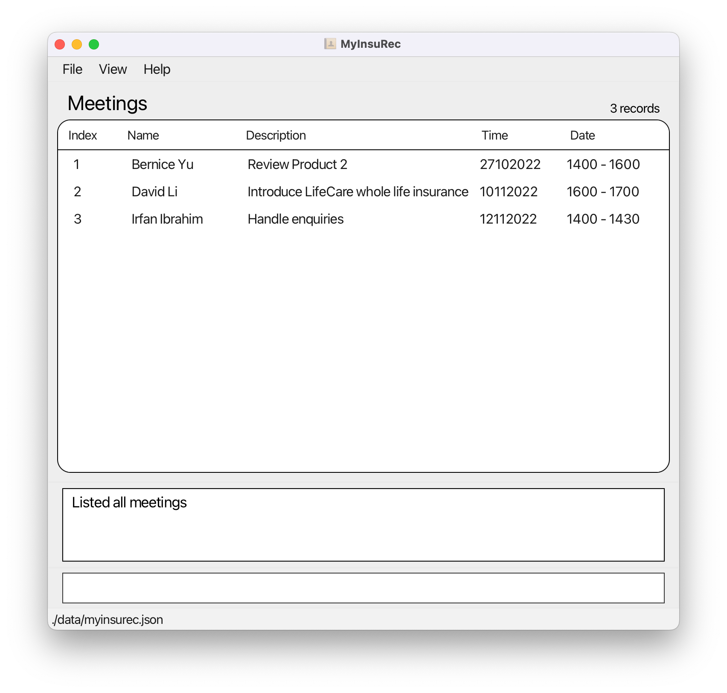

Meeting Information

Meeting List

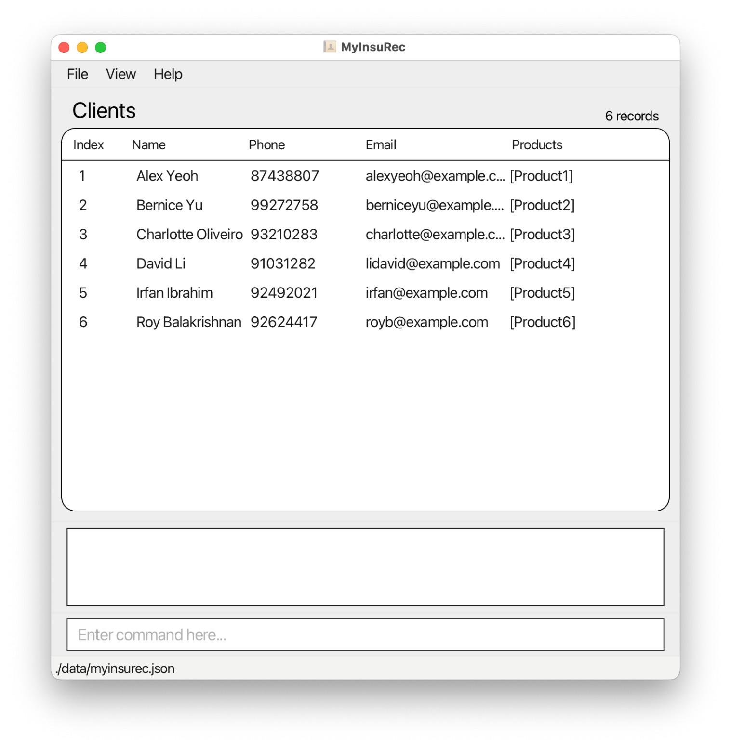

Number of Records

Client List

Command Input Box

Command Output Box

Client Information

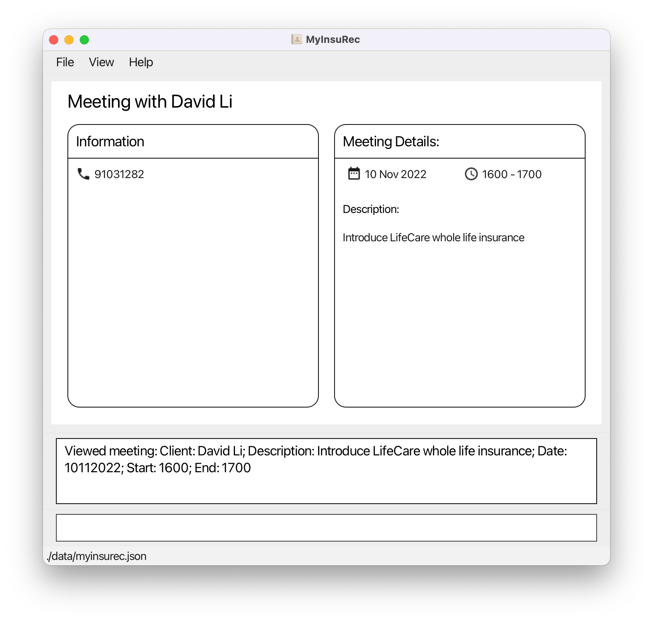

Meeting’s Information

Client’s Information

Meeting with Client

Product Name

Product List